Holds on your student account prevent you from performing certain tasks, such as registration. To lift the hold you need to complete a series of actions, but these depend on the type of Hold applied. There are different types of Holds, but you can view them all, and their Resolution Instructions, by following these steps in Workday.
Use this guide to view holds on your account.

View Holds
- On the Workday homepage, click the “Academics” app.

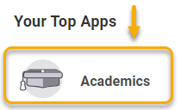

- On the Academics app homepage, locate the Registration Requirements box. In this box, locate the Holds tab and click the arrow to expand details.

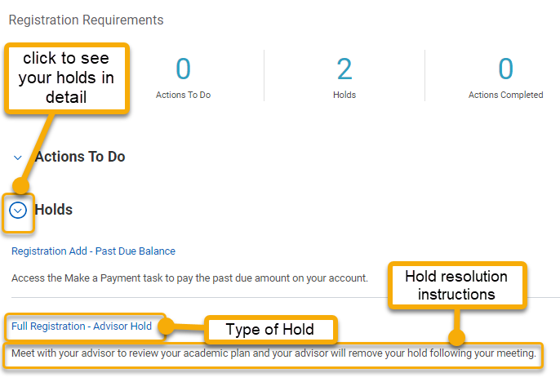
Student accounts will have holds at the beginning of the academic period. Different types of holds require different resolutions. Review each hold and the resolution instructions. Follow the instructions to lift the hold.
- For additional details, open the hold in a new tab and review. When finished, close the tab and return to the Academics app.

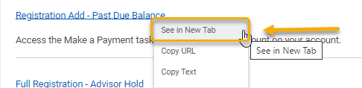
- The details page will provide a description, reason for the hold, and the resolution instructions.

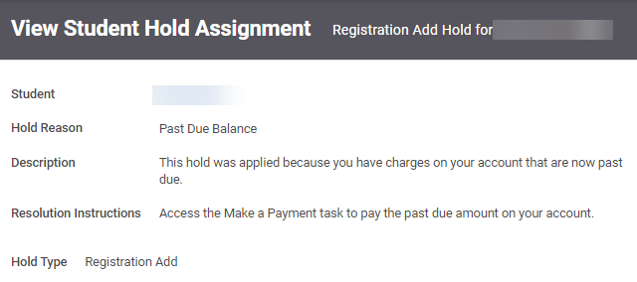
Some holds will prevent you from registering for classes. Be sure to resolve these holds before registration. If you have questions or concerns, contact your advisor.

